September 1, 2017

AMVETS Post 22
Route 411 S
Maryville, Tennessee 37801

RE: Knoxville Regional Veterans Mental Health Council Position

Dear Commander Mark Frederick,

The Knoxville Regional Veterans Mental Health Council (Council) met with the Department of Veterans Affairs Mountain Home VA Medical Center Executive Leadership team at the Council’s regularly scheduled monthly meeting on Thursday, August 10, 2017.

The Council acknowledged the extraordinary work and dedication of the leadership & members of AMVETS Post 22 (Post). The Council and the VA believe the Post is an important positive influence in the Blount County and their position on the Council will benefit not only the veterans and their family in Blount County but also the veterans in the VA Mountain Home Healthcare systems in eastern Tennessee.

Because of the visionary mission and selfless effort of the Post’s various creative projects, the Council has approved a position for a member of the Post on their Council.

I have included a copy of the Council’s Bylaws for your review and understanding of the mission of the Council. Currently the Post has two (2) members who belong to the Post; Karl Griffith and Ed Junod.

We invite the leadership of the Post to consider our request. If the Post approves our offer, the Post member would be installed as our newest Council member on September 14, 2017.

We look forward to your response.

Respectfully,

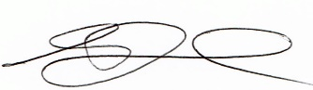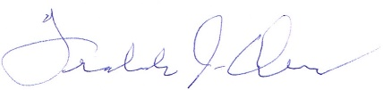

Edouard “Ed” Junod, Chairman Freddie J. Owens, Vice Chairman

