Invisible soldiers: America needs to recognize and celebrate its courageous female veterans

America needs to recognize and celebrate its courageous female veterans
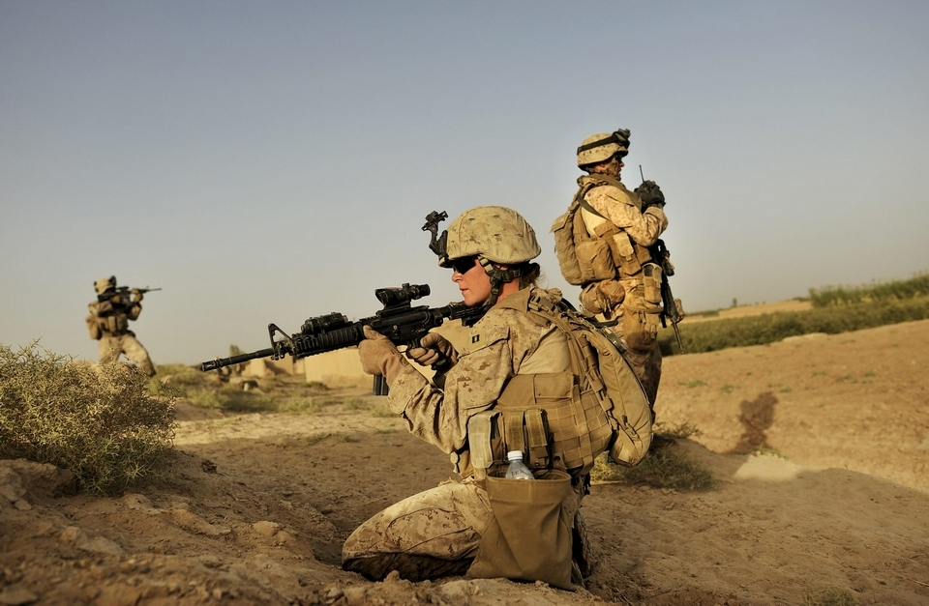

Marine Capt. Emily Naslund, who was part of a group of female Marines tasked with interacting with Afghan women, was on patrol in Marja, Afghanistan, in 2010 when her unit came under fire. She was one of many women who fought on the front lines in Iraq and Afghanistan. Photos by New York Times

Since 9/11, more than 200,000 women have been deployed to Iraq and Afghanistan, and more than 160 women have died in service to their country. Women have fought on the front lines as combat pilots and military police platoon leaders. They have received Silver Stars and Bronze Stars for Valor. Some have even joined special operations forces on combat missions.
Yet when people think of veterans, they rarely think of women.
As the veterans organization Mission Continues found in a survey out this month of female veterans, a “common theme among our respondents was a perception of invisibility both in the service and at home. While in uniform, nearly two-thirds of respondents said they had to work harder than men to prove themselves. When those women left the military, barely a third [37 percent] said they felt recognized, respected and valued by society for their contributions as veterans.”
One veteran in Minnesota told me recently that when she tried to join a local veterans organization, she was guided to the women’s auxiliary rather than the group for service members.
Another soldier based at Fort Bragg told me that she saw a mandatory counselor after her tour in Afghanistan, who said that even though she “did not see combat” and was “mostly on base,” she might have some re-entry issues. He had no idea that she had served an eight-month tour as part of a special operations team of women and had been on night raids several times a week throughout her deployment.
And a few months back, a North Carolina Air Force veteran who served in Kuwait set off a media storm when she told local reporters about a nasty note she discovered after she left her car in a spot marked “Veteran Parking.”
“This space is reserved for those who fought for America … not you,” read the missive Mary Claire Caine found stuck to her windshield.
“I think they took one look at me when I got out of my car and saw that I was a woman and assumed I wasn’t a veteran and assumed I hadn’t served my country,” Caine said at the time. “They have this image of what today’s American veteran is, and honestly, if you’ve served in the United States military, you know that veterans come in all shapes and sizes.”
Evidently America is still thinking small, even as women in uniform make strides on the country’s behalf.
Recent history is full of stories of women breaking new ground. The first woman to fly the F-35, the Air Force’s “premier fighter,” took to the skies last month. Years earlier she had flown combat missions in Afghanistan.
The Navy’s Blue Angels have their first female pilot this year.
Army Ranger school recently opened to women for the first time. No women made it through the first phase of the course. But 19 women qualified for it. And 42 percent of them made it through the grueling physical tests of the first four days, compared with 48 percent of men. Three will soon try once more.
The gap between women’s service and our perceptions has consequences; it makes female veterans’ re-entry into American society especially challenging.
Many do not self-identify as veterans and do not apply for the help and the services – from housing to health care to job placement – they could receive once they return home.
The Los Angeles Times reported that female veterans “commit suicide at nearly six times the rate of other women” – and perhaps not surprisingly, at nearly the same rate as their brothers-in-arms. In the piece, experts noted with concern that female veterans lack a “sense of belonging,” which can exacerbate depression.
In the two years I spent reporting on women who served on the front lines with special ops in 2011, I found that community sustained the soldiers in this pilot program while they were on the battlefield and, even more so, when they returned home.
While the rest of the Army and the entire United States had no idea what they had done and seen, they at least had one another to rely on. They are now family for life, one another’s career coaches and marriage counselors and best friends.
Such do-it-yourself community-building is critical and important, but female veterans also need a nation that recognizes and celebrates them.
Whenever female veterans do receive a mention in public life, the focus tends to be on their suffering. The media leads with stories of military sexual trauma and post-traumatic stress disorder.
Without doubt these are very real problems that must be addressed. According to the California Department of Veterans Affairs, nearly three-quarters of female veterans living in the state reported experiencing sexual harassment, and 40 percent reported experiencing sexual assault while in the military. Homelessness is also a critical issue.
But by defining female veterans by their victimhood, we leave out a crucial part of their service: their valor. Women have shown courage, grit and heart on the battlefield. They have already proved themselves on the front lines and in service, even if our national narrative hasn’t yet recognized it.
Gayle Tzemach Lemmon is a senior fellow at the Council on Foreign Relations and the author most recently of “Ashley’s War: The Untold Story of a Team of Women Soldiers on the Special Ops Battlefield.

