**3 graduate from Nashville’s expanding veterans court**

[Stacey Barchenger, sbarchenger@tennessean.com](http://www.tennessean.com/staff/30047/stacey-barchenger) 7:48 p.m. CST February 4, 2015

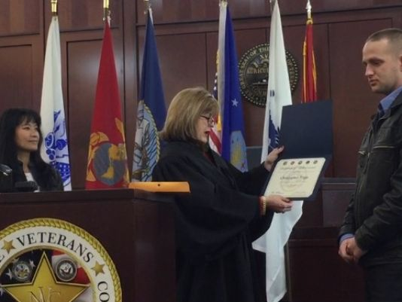

(Photo: Stacey Barchenger / The Tennessean)

Chris Tripp spent six years obeying the strict discipline of the U.S. Air Force, including during tours in Iraq and Kuwait.

When he was discharged in 2012, he found it challenging to readjust to life in Nashville, his hometown.

“Without everything there I went into a tailspin,” he said. “I found myself back with the same people I was with before the military, doing the same stupid stuff going to the same dumb clubs. Just, I guess, found myself around drugs and substances I had no business taking.”

Police caught Tripp once, and he would have had a felony drug charge on his record if it were not for Davidson County veterans court. The court is an alternative supervision program designed to help veterans who are charged with non-violent offenses. If they complete the program, their charges are expunged.

Tripp and two other men graduated from the program Wednesday. The ceremony was slightly delayed because an investigation of white powder found in an envelope in the criminal court clerk’s office — which turned out to be harmless — closed the courthouse.

The graduations are the first under Judge Melissa Blackburn’s tenure and come following a period of change and growth.

Davidson County has had a veterans court for about five years, but last fall the program got its first slice of federal funding. The U.S. Department of Justice committed $140,000 annually for the next three years. With that money, Blackburn has hired four staff members.

They now serve 47 veterans.

The graduation ceremony — and cake reception — on Wednesday was also a way to mark the successes of the program and the organizations that have given support. Those include Metro police, Operation Stand Down Tennessee, the Department of Veterans Affairs, the Tennessee Department of Mental Health and Substance Abuse Services and others.

“Thanks for giving me a chance to show that the actions that led to my arrest aren’t what define me,” Tripp told those who gathered in Blackburn’s courtroom.

Tripp said his arrest, and participation in the veterans court, helped give him the discipline he saw during his military service.

“Even though that wasn’t my shining moment,” Tripp said, “getting arrested put me back in touch with all the resources that provide that structure.”

Reach Stacey Barchenger at 615-726-8968 or on Twitter [@sbarchenger](http://twitter.com/sbarchenger).