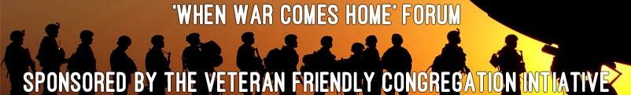

Hosted by the Knoxville Regional Veterans Mental Health Council’s

Faith-Based Community Committee

OVERVIEW:

There is an overwhelming desire by clergy to better serve the pastoral care needs of our veterans and their families. Currently, more than 40% of veterans seek direct counsel from their clergy. Research indicates more than 10,000 military members will reintegrate into our Tennessee communities in the coming year, seeking support and services from their clergy. The unique needs of veterans require an informed and educated clergy, equipped with programs that address their specific needs. A Veterans ministry will be a highly valuable and much needed service for returning active duty, as well as new, veterans and their families.

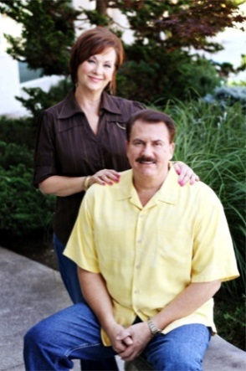

FEATURED KEYNOTE SPEAKER:

Dr. Ed King is the founder and senior pastor of Redemption Church, a thriving, growing church located in Knoxville, Tennessee. In addition to pastoring and supervising the church staff, Dr. King is president of the Power of the Word television outreach ministry. The show is broadcast nationally and internationally with access to over 1 billion viewers. He resides in Knoxville along with his wife and Co-Pastor, Nora, and their daughter, Laren. Dr. King has done extensive travel in over 60 countries, teaching and preaching the gospel, as well as conducting leadership conferences and evangelistic meetings around the world. He has ministered in large crusades where thousands have received salvation and healing. His strong anointing to teach faith has encouraged and strengthened many in the body of Christ. Pastor King is known to many as a pastor’s pastor and has great insight into church life. He has also been instrumental in helping to plant various new churches.

Pastor Ed King’s Military history
- Combat Vietnam Veteran
- Served March 1969 to April 1970
- Unit 240th AHC (Assault Helicopter Company)
- Bearcat
- Part of the 1st Aviation Brigade
- Flew in conjunction with the 9th Infantry & the 5th Special Forces
- Specialist 5th Class Crew Chief on UH1 helicopter (Huey)

FEATURED PRESENTERS:

. Veteran Friendly Congregation Initiative: Freddie Owens Chairman;
Chaplain Dennis Lovin, Co- Chairman
. Peter McCall: CareForTheTroops, Executive Director

THE AGENDA:

Master of Ceremonies: Freddie Owens

8:00 AM Registration

9:00 AM - Chaplain Dennis Lovin, Invocation
Special Welcome & Candle Ceremony by Freddie Owens,

9:15 AM – Knox County Mayor Tim Burchett, Opening Remarks

9:25 AM – Freddie Owens, Introductions of Featured Guest and Keynote Speaker

9:40 AM – Dr. Ed King, Senior Pastor of Redemption Church: Why a Military Ministry
Is Necessary

10:00 AM – Overview of the Veteran Friendly Congregation
Chaplain Dennis Lovin
Peter McCall, CareForTheTroops, Executive Director

10:20 AM – Morning Break

10:35 AM – Break Out Session One: “What”

11:05 AM – Break Out Session One Feedback

11:20 AM – Break Out Session One Q&A

11:35 AM – Lunch Break

12:15 AM – Break Out Session Two: “So What”

12:45 AM – Break Out Session Two Q & Q

01:15 AM – Break Out Session Three : “Now What”

01:45 AM – Break Out Session Three Groups: Q & A

02:05 AM – Wrap Up & Next Steps

02:25 AM – Closing & Candlelight Ceremony; A Moment of Silence for Veterans
Considering Suicide

02:40 AM – Veteran Friendly Congregations Networking and Registration

03:00 PM - Thank you for your concern for veterans and their families and
drive safely!!!

