Joseph “JL” Tucker Memorial Award

We Salute

Name

In Grateful Appreciation for Your Exceptional Passion & Tremendous Hard Work to Help the Knoxville Regional Veterans Mental Health Council and Vet to Vet Tennessee to help veterans and their families overcome adversity. Your contribution to the health and welfare of those who serve our nation and their families is a special gift.

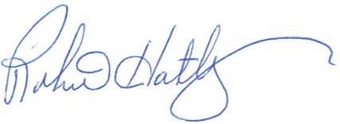
Done this eleventh day of January 2018
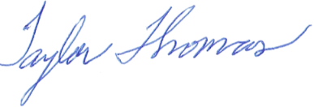
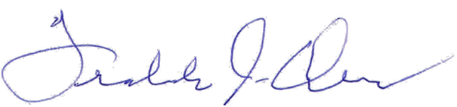

Freddie J. Owens, President Taylor Thomas, Outreach Officer Robert Hatley, Secretary
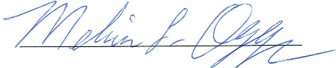
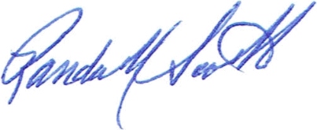

Randall Scott, Vice President Edouard “Ed” Junod, Treasurer Melvin Oggs, Chaplain

